

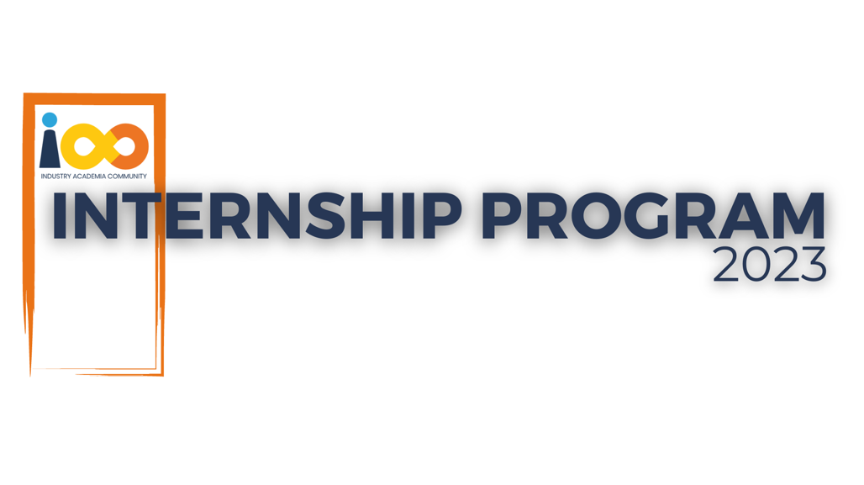

PROJECT REPORT

FULL STACK DEVELOPMENT  
  
CONNECTIN WEB APPLICATION

|  |  |  |  |
| --- | --- | --- | --- |
| **Created By:** | Shreyash Deogirkar | **Approved By:** | <Domain Lead Name> |
| **Created On:** | 24-07-2024 | **Approved On:** | DD-MMM-YYYY |

Page left blank intentionally

**INDEX**

**1** **PROJECT DETAILS** 2

**2** **SUMMARY** 2

**3** **INTRODUCTION** 2

3.1 Background 2

3.2 Stakeholders 2

3.3 Objectives 2

**4** **METHODOLOGY** 2

4.1 Considerations & Assumption 3

4.2 Approach 3

4.3 Activities 3

**5** **TARGETTED V/S ACHIEVED OUTPUT** 3

**6** **CONCLUSION** 3

**7** **APPENDICES** 4

7.1 Appendix A – Title 4

**General Instructions for using the Live Project Report Template**

* This template and the subsequent document created using this template is a confidential document and is the intellectual property of Cloud Counselage Pvt. Ltd. Circulating it outside of the organisation without the consent of Cloud Counselage Pvt. Ltd. is the breach of company policies and will lead to legal actions
* This template is a guideline document to communicate the implementation of design ideas and the results of the work to the stakeholders.
* The **text between inequality (< >) is to be replaced** by relevant text
* Please **remove the yellow highlight on the Text** between the inequality (< >). This is done to help you notice the text to be changed/replaced
* The text in *italics* highlighted in grey is just for reference and should be removed after adding the relevant text

# **PROJECT DETAILS**

|  |  |  |  |
| --- | --- | --- | --- |
| **Project Name** | Connectin | | |
| **Project Sponsor** | Tushar Topale | | |
| **Project Manager** | Harshada Topale | | |
| **Start Date** | 05-07-2024 | **Completion Date** | 22-07-2024 |

# **SUMMARY**

**1. Project Expectations:**

* **Core Features:** The project aimed to deliver a comprehensive web application designed to support higher education students in their professional development. Key features included user authentication, profile management, job and internship search functionalities, and networking tools.
* **User Experience:** The platform was expected to provide an intuitive and user-friendly interface, enabling students to easily navigate and utilize the features for career advancement.

**2. Need for the Project:**

* **Professional Growth:** In the current landscape, students require robust tools to bridge the gap between academic learning and professional experience. This project was needed to create a dedicated space where students could access job opportunities, connect with professionals, and develop relevant skills.
* **Enhanced Connectivity:** The project addressed the lack of a specialized networking platform for students, offering a solution to facilitate meaningful professional relationships and support career growth.

**3. Long-Term Benefits:**

* **Career Advancement:** The platform will help students in securing job and internship opportunities, improving their career prospects and professional readiness.
* **Professional Networking:** By providing a space for students to connect with industry professionals, the platform fosters valuable networking relationships that can lead to mentorship and future career opportunities.
* **Skill Development:** Through features like skill endorsements and job recommendations, the platform supports continuous learning and skill enhancement, aligning student capabilities with industry needs.

In summary, the project was designed to meet the critical need for a professional development platform tailored to higher education students. Its long-term benefits include enhanced career opportunities, stronger professional networks, and continuous skill development, all of which contribute to better career outcomes for students.

# **INTRODUCTION**

## Background

In today's uncertain environment, the path to professional growth hinges on staying informed about industry trends, continually developing new skills, and building a strong professional network. Success in one's career is often driven by continuous learning and the support of a network of professionals who can offer guidance and share opportunities. Therefore, a platform that enables users to find appropriate job or internship opportunities, fosters the creation and maintenance of professional relationships, and provides tools for skill development would be immensely beneficial for career advancement.

## Stakeholders

**Primary Stakeholders:**

**Higher Education Students**:

* + **Role**: End-users of the platform who will benefit from job and internship opportunities, professional networking, and skill development resources.
  + **Needs**: Access to job listings, internship opportunities, professional networking features, and skill-building resources.

**Educational Institutions**:

* + **Role**: Partners who might use the platform to enhance their students' career prospects and integrate the platform into their career services.
  + **Needs**: A tool that can provide students with opportunities and support professional development.

**Employers and Recruiters**:

* + **Role**: Entities seeking to connect with and recruit talented students for job placements and internships.
  + **Needs**: Access to a pool of qualified candidates, effective tools for job postings and candidate search.

## Objectives

* **Objective**: Create a platform with login/register functionality, a search bar, profile sections, and endorsements.

**Achievement**: The platform includes a complete set of features such as user authentication, a search bar, user profiles, and the ability to endorse skills.

* **Objective**: Ensure the platform operates smoothly as a single-page application to enhance user experience.

**Achievement**: The platform has been successfully developed as an SPA, providing a seamless and responsive user experience.

* **Changes to Objectives**:

The objective of a user-friendly design has been expanded to include accessibility improvements and mobile responsiveness, ensuring a better experience across all devices.

Users can also post updates, like, and comment on posts within the platform, fostering increased interaction and engagement.

# **METHODOLOGY**

These conventions are all about the positions of line breaks, how many characters should go on a line, and everything in between.

## Considerations & Assumption

**Time Constraints:**

* Limited time for development and testing phases.
* Assumption: The project will prioritize essential features and implement a phased rollout to ensure timely delivery.

**Technical Constraints:**

* Dependency on third-party authentication services (e.g., Clerk) and cloud storage (e.g., Cloudinary).
* Assumption: These services will remain stable and provide necessary support during the project lifecycle.

**Challenges:**

**Integration with Third-Party Services:**

* + Ensuring seamless integration with authentication and cloud storage services.
  + Assumption: Comprehensive documentation and support from these services will facilitate smooth integration.

**Reasons for Assumptions:**

* + Relying on comprehensive documentation and support for third-party services to ease integration challenges.
  + Assumption: Access to detailed documentation and responsive support will address integration issues effectively.

## Approach

**Identifying the Problem:**

* **Problem Statement:** Higher education students lack a dedicated platform for ongoing professional development and networking.
* **Evidence & Background:** In a climate of uncertainty, students require a platform that provides industry knowledge, skill development, and networking opportunities to support their career growth. There is a clear need for a solution that facilitates job and internship searches, fosters professional connections, and offers resources for skill enhancement.

**Defining Objectives:**

* **Objective:** Develop a web application tailored for higher education students that enables job and internship searches, facilitates professional networking, and supports continuous learning. The platform will feature essential components like user authentication, profile management, a searchable directory, and tools for creating and managing professional groups.

**Designing the Solution:**

* **Feature Set:** Implement core functionalities including secure login/register, comprehensive profile management, a dynamic feed for interactions, and a sidebar for user profile visibility and group management.
* **User Interface:** Design an intuitive and user-friendly interface that balances functionality with a clean, professional aesthetic.

**Implementation Strategy:**

* **Technology Stack:** Utilize the NextJs, MongoDB, React etc. for a cohesive and scalable development environment, leveraging its strengths in both front-end and back-end development.
* **Integration:** Use third-party services for authentication and cloud storage to streamline user management and media handling.

**Testing & Optimization:**

* **Testing:** Perform rigorous testing to ensure all features function as expected, and the user experience is smooth and intuitive. Address any issues or bugs identified during the testing phases.
* **Optimization:** Continuously optimize performance to handle increasing user numbers and data volume, ensuring the application remains responsive and reliable.

## Activities

**1. Requirement Gathering**

Conducted interviews and surveys to identify user needs and expectations.

Analyzed competitors to determine essential features and industry standards.

**2. Project Initiation**

Defined the project’s purpose, scope, and objectives through a project charter.

Assembled the development team and identified required resources and tools.

**3. Project Planning**

Created a detailed project plan with scope, timeline, and milestones.

Identified potential risks and developed strategies for mitigation.

**4. Project Execution**

Developed and integrated backend and frontend components as per requirements.

Monitored progress and adjusted the development process to stay on track.

**5. Testing**

Performed unit and integration testing to ensure functionality and stability.

Conducted user acceptance testing to validate the application’s usability.

**6. Deployment**

Released the application to a staging environment for final review.

Deployed to production and monitored for performance and user feedback.

# **TARGETTED V/S ACHIEVED OUTPUT**

**1. Targeted Output:**

* **Feature Completion:** Implement a full-featured web application including user authentication, profile management, job/internship search, and networking tools.
* **Timeline:** Complete the project within the planned timeline with all core functionalities implemented and tested.

**Achievements:**

* **Feature Completion:** Successfully developed and integrated core features such as user registration, profile management, and job search. However, advanced features like group management and enhanced search capabilities were partially implemented.
* **Timeline:** The project was completed within the planned timeline, though some advanced features were deferred to a later phase for additional development.

**Reason for Deviation:**

* **Complexity of Features:** Some advanced features, such as group management, required more time than initially estimated due to unexpected technical challenges and the need for additional refinements.
* **Resource Constraints:** Limited resources and competing priorities led to a focus on core functionalities, causing a delay in implementing additional features.

**2. Targeted Output:**

* **User Acceptance:** Achieve a high level of user satisfaction and positive feedback through usability testing and user acceptance tests.
* **Performance Metrics:** Ensure the application meets performance benchmarks, including load times and responsiveness.

**Achievements:**

* **User Acceptance:** Received positive feedback for core functionalities, but additional features in the feedback were not fully implemented by the initial deployment.
* **Performance Metrics:** The application met most performance benchmarks, though some areas, such as search functionality under heavy load, showed room for improvement.

**Reason for Deviation:**

* **Testing Constraints:** Limited time and resources constrained comprehensive testing of all features, leading to less-than-ideal performance in specific scenarios.
* **Feature Complexity:** The complexity of implementing certain features led to performance trade-offs that were not fully optimized before deployment.

**Lessons Learned:**

1. **Detailed Planning:** More granular planning and resource allocation for advanced features can help manage complexity and avoid delays.
2. **Iterative Development:** Implementing features in smaller increments and gathering user feedback early can help identify issues sooner and adapt accordingly.
3. **Performance Testing:** Allocate sufficient time for performance testing under various conditions to ensure that all features meet user expectations and performance benchmarks.

# **CONCLUSION**

**Usefulness for Stakeholders**

**1. Professional Development:**

* **For Students:** The platform offers a valuable resource for discovering job and internship opportunities, building professional networks, and developing skills crucial for career advancement.
* **For Educational Institutions:** Enhances student career readiness and job placement, thereby contributing to improved outcomes and satisfaction among students.

**2. Networking and Recruitment:**

* **For Employers:** Provides direct access to a pool of motivated students seeking career opportunities, facilitating the recruitment of suitable candidates.
* **For Professionals:** Allows for mentoring and networking, helping industry professionals connect with emerging talent and contribute to their development.

**Future Scope**

**1. Feature Expansion:**

* **Group Management:** Adding features for professional group creation and management to foster collaboration and engagement among users.
* **Skill Endorsements:** Implementing systems for endorsing skills and issuing certifications to enhance user profiles and their professional credibility.

**2. Enhanced Functionality:**

* **Personalized Recommendations:** Developing algorithms to offer tailored job and internship suggestions based on user profiles and interactions.
* **Analytics Tools:** Integrating analytics to provide users with insights on profile performance, connection growth, and engagement levels.

**3. Scalability and Accessibility:**

* **Scalability Improvements:** Enhancing the platform’s infrastructure to support growing user numbers and data volumes efficiently.
* **Mobile Access:** Exploring the development of a mobile app to improve accessibility and user engagement on various devices.

# **APPENDICES**

## Appendix A – Login/Register

|  |  |
| --- | --- |
| **Identification** | Login Screen/ Register Screen  Location: Authentication module |
| **Type** | Form/User Interface |
| **Purpose** | Authenticates users by validating credentials and manages redirection post-login.  Allows users to create new accounts and handles account creation. |
| **Subordinates** | Login form with fields for username and password  Registration form with fields for user details |
| **Dependencies** | Depends on authentication service for credential validation.  Redirects to Profile Screen or shows error messages (Issue Violation Screen Part I) if login fails.  Redirects to Profile Screen or shows errors using Issue Violation Screen Part I if registration fails. |
| **Interfaces** | * Login API endpoint * Error messages for failed authentication * Registration API endpoint * Error messages for failed registration |
| **Resources** | Authentication API service  Registration API service |
| **Processing** | Validates user credentials and redirects to the Profile Screen on success.  Handles new user account creation and redirects to Profile Screen on success. |
| **Data** | User credentials (username, email, password) |

## Appendix A – Main Page

|  |  |
| --- | --- |
| **Identification** | Main Menu Screen  Location: Main entry point of the application |
| **Type** | User Interface |
| **Purpose** | Provides navigation to various parts of the application, such as the profile page, feed, and other functionalities. |
| **Subordinates** | Navbar with links to Home, Profile, Feed, and Settings  Sidebar with quick links to posts, skills, and experience |
| **Dependencies** | Relies on the user authentication state to display the correct navigation options.  Other components: Profile Screen, Feed Page, Settings Page |
| **Interfaces** | User interface elements (buttons, links)  No explicit error messages; errors are handled by the respective pages. |
| **Resources** | Frontend frameworks/libraries (React, Next.js) |
| **Processing** | Displays navigation options based on user state. |
| **Data** | User authentication state  Navigation settings |

## Appendix A – Logout

## 

|  |  |
| --- | --- |
| **Identification** | Logout  Location: Authentication module |
| **Type** | Control Procedure |
| **Purpose** | Ends the user session and redirects to the Login Screen or Home Page. |
| **Subordinates** | Session termination procedure |
| **Dependencies** | Requires user authentication to terminate the session. |
| **Interfaces** | Session management |
| **Resources** | Session management service |
| **Processing** | Logs out the user and handles redirection. |
| **Data** | Session data |